Anxiety Disorders and Their Treatments

I. Anxiety Disorders
Anxiety disorders are among the most common mental health concerns globally, affecting millions of individuals across diverse societies and cultures. While anxiety is a fundamental human emotion, it becomes a mental health concern when it is "excessive and persistent," characterized by "feelings of uneasiness, fear, nervousness, or dread, accompanied by restlessness and tension." In 2019, 301 million people worldwide were estimated to have an anxiety disorder, making them the most prevalent of all mental disorders.
Common Symptoms of Anxiety Disorders include:
- Trouble concentrating or making decisions
- Feeling restless
- Experiencing nausea or abdominal distress
- Having heart palpitations
- Sweating, trembling or shaking
- Trouble sleeping
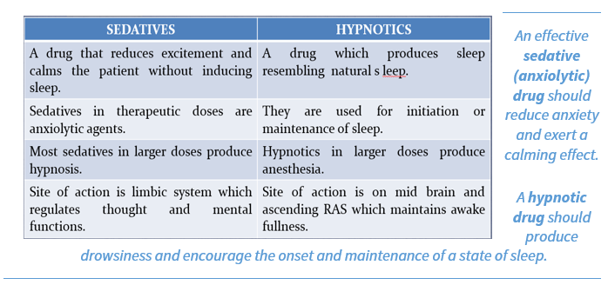
Types of Anxiety Disorders
The sources identify several distinct types of anxiety disorders:
- Generalized Anxiety Disorder (GAD): Characterized by "a constant state of worry about everyday life, even without any clear cause or reason." Individuals with GAD often experience physical symptoms like "rapid heartbeat, fatigue, and muscle tension."
- Social Phobias (Social Anxiety Disorder): Involves "intense fear of being judged or analyzed in social situations," leading to avoidance behaviors that can impact "work, relationships, and overall life satisfaction."
- Phobias: Defined by "a specific and intense fear response toward objects or situations that typically pose little or no threat." These fears are "often unequal to the actual danger they represent," such as aviophobia (fear of flying).
- Panic Disorder: Marked by "sudden and unpredictable attacks of intense fear," often accompanied by physical symptoms such as "heart palpitations, sweating, and shortness of breath, dizziness, or chest pain
- Post-traumatic Stress Disorder (PTSD): Triggered by "a traumatic event that leaves lasting emotional scars," resulting in "ongoing anxiety, nightmares, flashbacks, and hyper arousal even years later."
B. Related Disorders
Anxiety disorders are often interconnected with other mental health conditions, such as:
- Obsessive-Compulsive Disorder (OCD): Characterized by "disturbing thoughts (obsessions) that are distressing and cause individuals to perform repetitive behaviors (compulsions) to alleviate the fear or prevent negative outcomes, even when those actions may not have a rational basis in reality." Common obsessions include "fear of germs or contamination" and "fear of losing control," while common compulsions include "excessive cleaning or handwashing" and "repeatedly checking things."

II. Treatment Approaches for Anxiety
Treatment for anxiety disorders often involves a combination of pharmacological and psychotherapeutic interventions.

A. Pharmacological Treatments
Pharmacological treatments aim to alleviate anxiety symptoms by targeting neurotransmitter systems in the brain.
- Benzodiazepines: These drugs "often provide fast-acting relief from acute anxiety symptoms, promoting relaxation and reducing feelings of panic or worry." However, "long-term use is typically not advised due to potential dependence and side effects." They are classified by duration of action:
    - Long-acting: Clonazepam, Diazepam, Flurazepam
    - Intermediate-acting: Lorazepam, Oxazepam, Temazepam
    - Short-acting: Triazolam, Midazolam
  - Mechanism of Action: Enhance GABA activity by binding to GABA receptors, leading to a calming effect on neuronal activity. Prolong the frequency of chloride channel opening at GABA receptors.
  - Side Effects: Sedation, drowsiness, cognitive impairment (anterograde amnesia), respiratory depression, dependence, and withdrawal.
    - Flumazenil is an antagonist used in overdose.
- Antidepressants: "Some antidepressant medications can also help manage anxiety by balancing neurotransmitters (chemical messengers) in the brain." Types include:
  - Selective Serotonin Reuptake Inhibitors (SSRIs): "Increase serotonin levels in the synaptic cleft" by inhibiting reuptake. Examples include Fluoxetine (Prozac), paroxetine (Paxil), sertraline (Zoloft), citalopram (Celexa), escitalopram (Lexapro).
  - Serotonin/Noradrenaline Reuptake Inhibitors (SNRIs): Target serotonin and noradrenaline reuptake. Examples include Venlafaxine (Effexor), Duloxetine (Cymbalta).
  - Tricyclic Antidepressants (TCAs): Inhibit reuptake of serotonin, norepinephrine, and sometimes histamine. Examples include Imipramine (Tofranil), Amitriptyline (Elavil).
  - Monoamine Oxidase Inhibitors (MAOs): Block enzymes that break down serotonin, norepinephrine, and dopamine. Examples include Isocarboxazid (Marplan), Phenelzine (Nardil). MAOs "can also have serious side effects like blood pressure fluctuations."
- Melatonin Receptor Agonists: Mimic melatonin's action to regulate sleep and circadian rhythms, leading to a calming effect. Examples include Ramelteon (Rozerem) and Tasimelteon (Tasmar).
  - Ramelteon is a selective agonist at MT1 and MT2 melatonin receptors in the suprachiasmatic nuclei (SCN) promotes "sleep onset insomnia,"
  - "A novel hypnotic drug prescribed specifically for patients who have difficulty in falling asleep."
  - "These drugs have no direct effects on GABAergic neurotransmission in the central nervous system."
    - Cautions: Caution for individuals with liver dysfunction.
  - Tasimelteon is an agonist at the MT2 receptor is used for "non-24-hour sleep-wake disorder." including delayed sleep phase syndrome and jet lag.
- Barbiturates: While historically used for anxiety, insomnia, and anesthesia, their use has "declined significantly in favor of newer anesthetic agents like propofol due to concerns regarding safety and effectiveness" and "high potential for abuse and addiction."
    - Short-Term (Ultra-Short-Acting) Barbiturates: Thiopental (Pentothal), Methohexital (Brevital).
    - Intermediate-Term Barbiturates: Secobarbital (Seconal), Amobarbital (Amytal).
    - Long-Term (Long-Acting) Barbiturates: Phenobarbital (Luminal), Mephobarbital (Mebaral).
  - Mechanism of Action: Prolong the duration of chloride channel open state at GABA receptors, leading to "more sustained inhibition of neuronal activity."
  - Clinical Uses: Primarily for "seizure control" (Phenobarbital) and historically for "anesthesia" (Thiopental). Also used in "assisted suicide" (Pentobarbital).
  - Toxicity: High risk of overdose, leading to CNS depression, respiratory depression, and death. "There is no specific antidote for barbiturate overdose."
- Antihistamines: Some can have a calming effect by "reducing hyperactivity in the central nervous system." Examples include Diphenhydramine (Benadryl).
- β-Adrenoceptor Antagonists: Block adrenaline receptors, reducing heart rate and blood pressure, thereby alleviating anxiety symptoms. Example: Propranolol (Inderal), useful for "panic attacks and other acute anxiety events."
- Antiepileptic Drugs: Primarily for seizures, but also effective for specific anxiety disorders. Examples include Gabapentin (Neurontin), Pregabalin (Lyrica).
- 5-HT1A Receptor Agonists (Buspirone): Selective anxiolytic drug acts as a partial agonist at serotonin 5-HT1A receptors, inhibiting excessive serotonin release. "Buspirone is considered the first-line medication for generalized anxiety disorder (GAD)."
  - Key Features: "Relatively long time it takes for the drug to achieve its therapeutic effect (weeks)." Lacks sedative effects and does not lead to "rebound anxiety upon discontinuation, and there's no evidence of withdrawal symptoms."
  - Side Effects: Non-specific chest pain, tachycardia, dizziness, headache.
- Atypical Antipsychotics: Used for certain types of anxiety due to action on neurotransmitter systems. Examples: Olanzapine (Zyprexa), Quetiapine (Seroquel).
- Zolpidem: A non-benzodiazepine hypnotic for sleep onset insomnia.
  - Mechanism of Action: Selectively binds to the GABAA receptor subtype containing the α1 subunit, enhancing GABA's inhibitory effects.
  - Key Features: "Short half-life (2 hours)" minimizes morning drowsiness.

B. Psychotherapeutic Approaches
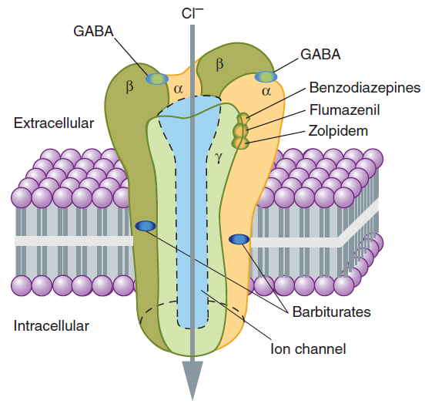
- Cognitive Behavioral Therapy (CBT): "Addresses Negative Thought Patterns." This approach "helps individuals identify and challenge negative thought patterns that contribute to their anxiety, replacing them with more adaptive and helpful ways of thinking." CBT is described as the "gold standard for psychotherapy."
- Acceptance and Commitment Therapy (ACT): "Focuses on acceptance and commitment to values-driven actions despite intense emotions or anxieties." It helps individuals "gain greater control over their lives and reduce the impact of anxiety on their overall well-being."

III. Detailed Review of Key Drug Classes
A. Benzodiazepines
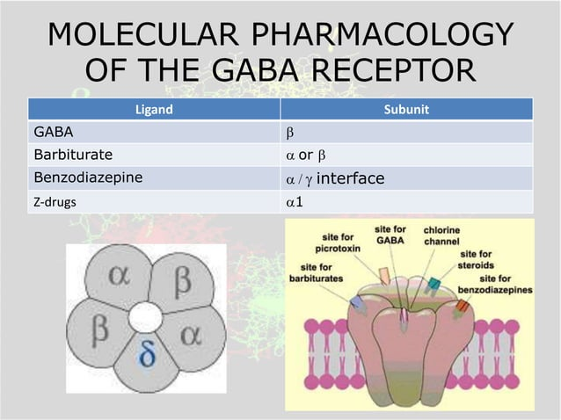
Benzodiazepines are a widely prescribed class of psychoactive drugs, used for anxiety disorders, insomnia, seizures, and muscle relaxation. Chlordiazepoxide was the prototype discovered in 1961.
1. Pharmacological Mechanisms:
- Benzodiazepines "enhance GABA activity" by binding specifically to a high-affinity site on α subunit/γ subunit interface of GABAA receptors. This "facilitates enhanced chloride channel opening induced by GABA, thus increasing inhibition in the neuron."
  - GABA_{A} receptors are pentameric assemblies of proteins, each subunit contributing to receptor function. These subunits consist of α, β, and γ subunits, forming diverse combinations. The precise structure allows benzodiazepines to bind specifically at a high-affinity site on α subunit/γ subunit interface.
2. Clinical Applications:
- Anxiety Disorders: "Widely prescribed for anxiety disorders like generalized anxiety disorder (GAD) and panic disorder, where quick symptom relief is desired." (Diazepam, lorazepam, clonazepam).
- Insomnia: Short-acting benzodiazepines like triazolam can "effectively induce sleep."
- Seizures: Clonazepam and diazepam are "essential in the treatment of various seizure types" due to their anticonvulsant properties.
- Muscle Relaxation: Diazepam is commonly prescribed for conditions like multiple sclerosis or cerebral palsy.
3. Pharmacokinetics:
- Generally "well absorbed."
- "Peak plasma concentration in 1 hour."
- "Very high lipid soluble and highly protein bound."
- "Cross placental barrier during pregnancy."
- Administered "Orally, IV, IM."
- "High therapeutic index, thus making them quite safe."
- Metabolized in the liver (Phase I: microsomal oxidation by CYP3A4, Phase II: conjugation to glucuronides for urine excretion).
Effects on Sleep:
- "Latency of sleep onset is decreased (time to fall asleep)."
- "Duration of stage 2 NREM (non-rapid eye movement) sleep is increased."
- "Duration of REM (rapid eye movement) sleep is decreased."
- "Duration of stage 4 NREM slow-wave sleep is decreased."
4. Drug Interactions:
- Drug Interactions: Additive effects with other CNS depressants (narcotics, alcohol), reduced effect of antiepileptic drugs, avoid concurrent use with OTC antihistaminic and anticholinergic drugs.
5. Side Effects:
- Sedation and Drowsiness: Common, can impair daily activities like driving.
- Cognitive Impairment: Long-term use linked to "memory weakening, a condition known as anterograde amnesia."
- Dependence and Withdrawal: Prolonged use can lead to physical and psychological dependence, with severe withdrawal symptoms including "tremors, anxiety, insomnia, seizures."
6. Benzodiazepine Antagonists (Flumazenil):
- "A GABA receptor antagonist that rapidly reverses the effects of benzodiazepines."
- Administered "intravenous (IV) administration only."
- Mechanism: Flumazenil acts as a GABA receptor antagonist, binding to receptors and blocking benzodiazepine-induced inhibition.
- Clinical Uses: Useful in treating "over dosage or accidental exposure to benzodiazepines. Onset is rapid, but the duration is short, with a half-life of about 1 hour, requiring repeated doses."
- Common adverse effects: "Dizziness, nausea, vomiting, and agitation."
  - "Seizures and cardiac arrhythmias may occur following flumazenil administration when BDZ are taken with tricyclic antidepressants (TCAs)."
  - "It also blocks many of the actions of zolpidem, zaleplon, but does not antagonize the central nervous system effects of other sedative-hypnotics."
B. Barbiturates
Barbiturates are sedative-hypnotic drugs, largely replaced by safer alternatives but still relevant in specific contexts. Discovered in 1864.
1. Mechanism of Action:
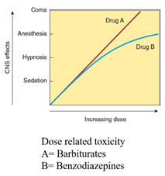
- "Unlike benzodiazepines that increase chloride channel opening frequency," barbiturates "prolong the duration of these channels' open state" at GABA receptors, resulting in "more sustained inhibition of neuronal activity."
2. Clinical Uses:
- Seizure Control: Phenobarbital is effective in managing epilepsy, particularly as a "second-line option" for various seizure types.
- Anesthesia: Thiopental (Pentothal) was a mainstay but has "declined significantly."
- Sedation: Historically used, but modern shift to safer sedatives like benzodiazepines and non-benzodiazepine sedatives (zolpidem) due to "superior safety profile with less potential for dependence."
- Assisted Suicide: Pentobarbital is utilized in some countries for euthanasia.
3. Overdose/Toxicity:
- Carry a "considerable risk for overdose and toxicity" leading to "drowsiness and confusion to coma, respiratory depression, and ultimately death."
- High potential for "physiological dependence" and tolerance.
- "No specific antidote for barbiturate overdose."
4. Contraindications:
- Contraindicated in patients with porphyria.
C. Orexin Receptor Antagonists
- Mechanism of Action: Block the action of orexin A and orexin B (neuropeptides promoting wakefulness) by binding to orexin-1 and orexin-2 receptors in the hypothalamus. This reduces wakefulness and promotes sleep without general CNS depression.
  - Example: Suvorexant
  - Note: Loss of orexin neurons is associated with narcolepsy.
D. Non-benzodiazepines (Z-Drugs)
Benzodiazepine-like effects, primarily for insomnia, with similar benefits and risks but different chemical structures.
Most Important:
Examples: Collectively known as "Z-drugs" (e.g., zolpidem, zaleplon, zopiclone, eszopiclone) due to their names often starting with "Z". They are psychoactive, depressant, sedative, hypnotic, and anxiolytic drugs. While chemically distinct from benzodiazepines, "they act in a similar way to benzodiazepines" and "have similar long-term usage problems."
- Mechanism of Action: Like benzodiazepines, they are "positive allosteric modulators of the GABAA receptor" and "exert their effects by binding to and activating the benzodiazepine site of the receptor complex."
- Classes: Major chemical classes include Imidazopyridines (e.g., zolpidem), Pyrazolopyrimidines (e.g., zaleplon), and Cyclopyrrolones (e.g., eszopiclone, zopiclone).
- Uses: Exclusively for the treatment of mild insomnia.
- Effectiveness: First doses are effective. Long-term use (beyond 7-10 days for zolpidem/zaleplon) leads to "loss of efficacy from tolerance."
- Recommended dose: 5-10 mg at bedtime (maximum 20 mg).
- Risks and Side Effects:
  - Tolerance and Addiction: Long-term use is "not recommended as tolerance and addiction can occur."
  - Dependence and Withdrawal: Should not be discontinued abruptly if taken for more than a few weeks due to "risk of rebound withdrawal effects, which may resemble those seen during benzodiazepine withdrawal."
  - Depression Risk: An analysis found these drugs "more than doubled the risks of developing depression compared to those taking placebo pills," suggesting they "may be contraindicated in patients with or at risk of depression."
- Can interact with medications like cimetidine.

